**Exercise 2**

Frameworks and libraries

**Introduction**

HTML5 is a mark-up language that is mostly used by web developers and designers in order to structure and present content on web pages in an effective and dynamic way. It includes an element known as canvas which uses JavaScript in order to create a lot of exciting content such as animations and games. The canvas element makes it very easy for designers to convert a boring web page to something a lot more interesting. However, in the real world dynamic content is difficult to implement and there is never much time to create these functions from scratch hence, designers often use JavaScript frameworks and/or libraries to speed up the process and attain an effective and professional piece of work.

**About Frameworks and Libraries**

JavaScript libraries and frameworks are difficult to distinguish as they are very similar to each other and perform the same job. The subtle difference is that a JavaScript library is a collection of pre written JavaScript that makes it easier to develop web applications. An example of a most commonly used JavaScript Library is jQuery. It is widely used by even the biggest companies such as Google and Microsoft as it helps to get the job done with very little coding of JavaScript. Libraries uses DOM (Document Object Model) /API’s which helps to perform tasks faster and more efficiently as you can simply select the name of an object and call it with only a few lines of code.

On the other hand, a framework is said to be more complex and is referred as a whole collection package which includes all the different components from tool sets to support programmes to help programmers accomplish a certain task. They provide the basic structure of a web page or application which the user may alter to fit their own functionality. Moreover, frameworks include a few key features such as inversion of control which is used to control the flow of user interaction. Also, frameworks are not always directly modifiable – they include fixed code that cannot be altered however, they may include custom stylesheets which users can use to control their own functions.

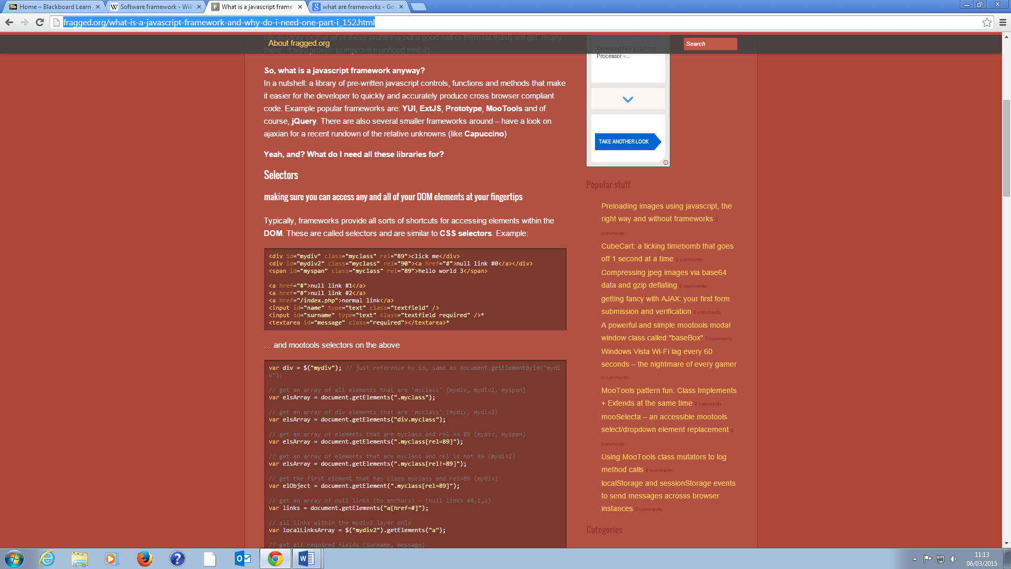Below is an example of DOM selectors used by frameworks and libraries. These are shortcuts which help to easily call the different elements.

**Types of frameworks/libraries**

As web technology is increasing, there are a range of different frameworks/libraries that are made available for developers to use to help create interesting content each time. Different framework packages may provide different controls and functions where some are more advanced than others. Here, I will be analysing frameworks and libraries that are used in HTML5 Canvas to create and/or design exciting graphics and other media such as audio and video.

<http://fragged.org/what-is-a-javascript-framework-and-why-do-i-need-one-part-i_152.html>